LETTER FORMAT

Times New Roman # 11
Align Left
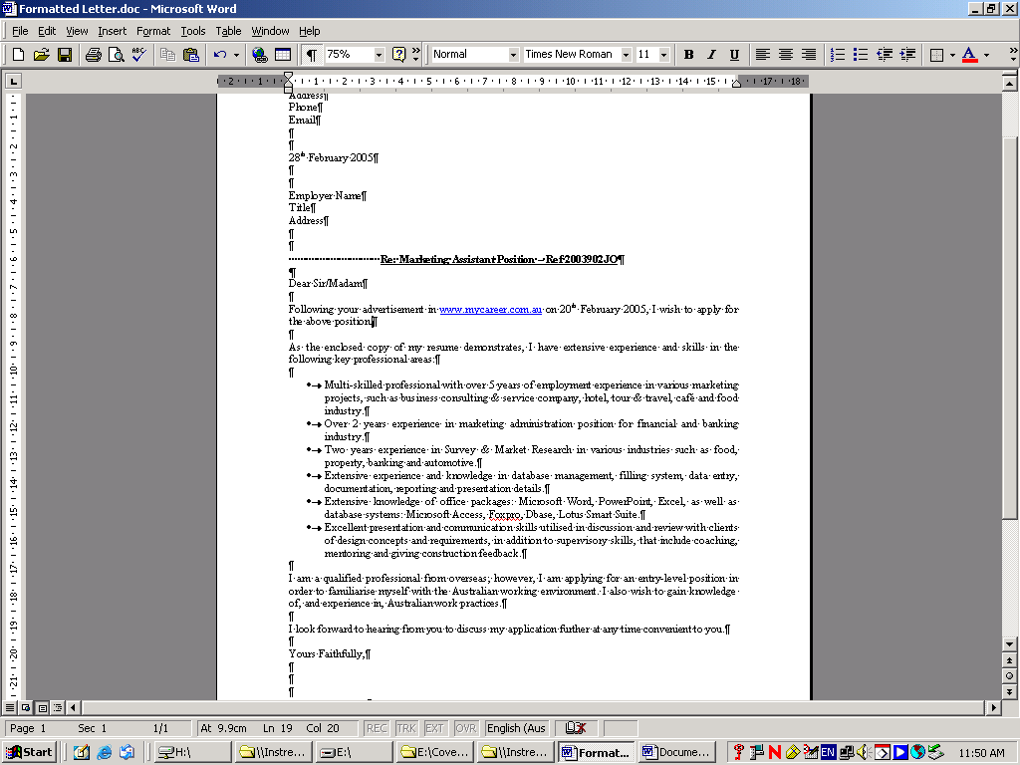
Spacing see below

